Managing Resources using ARM

## Demo: Using Visual Studio to Deploy an Azure Template

1. Connect to LABVM and Open Visual Studio.
2. Within Visual Studio 2015 click **File**, **New**, and **Project**.

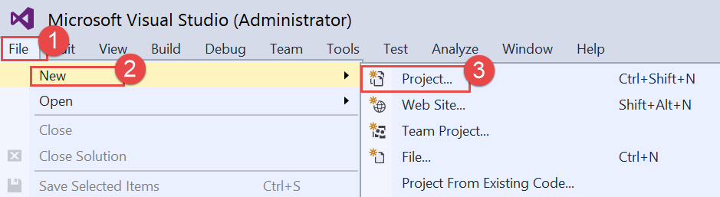

1. Navigate to **Templates**, **Visual C#**, **Cloud**, and select **Azure Resource Group**.

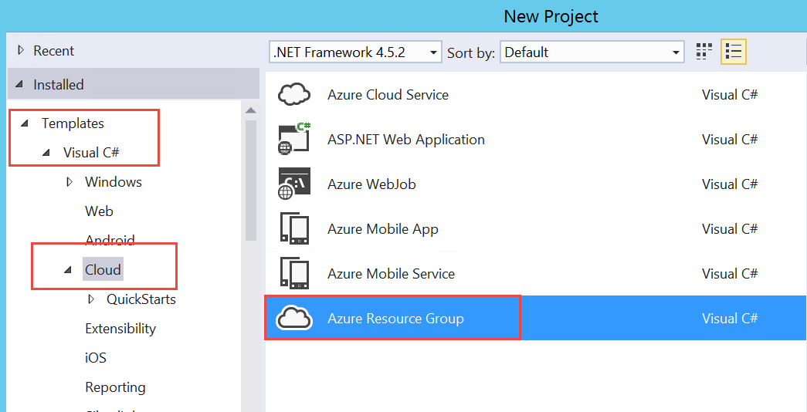

1. Change the name of the solution to: **ARMLabIntro** and the location to **C:\OpsgilityTraining**, and then click **OK**.

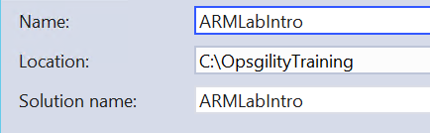

1. In the Select Azure Template scroll down and select the Ubuntu Server and click

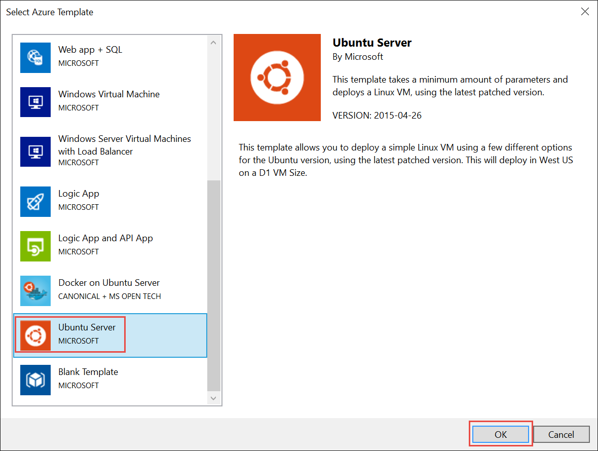

1. Expand the **ARMLabIntro** project, then expand the **Templates** folder, and open the **LinuxVirtualMachine.json** file.

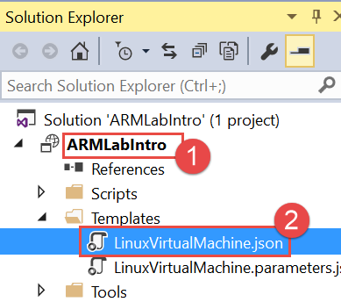

1. Move to the JSON Outline Window and click the arrow next to resources to show the pieces of the Ubuntu VM.

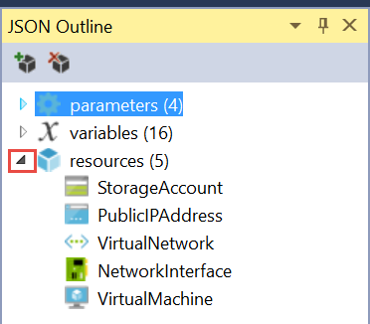

1. Right Click on the resources and click Add New Resource

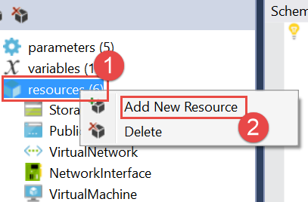

1. Scroll down and select the Network Interface and Name it “**NIC2**”. Then click **Add**.

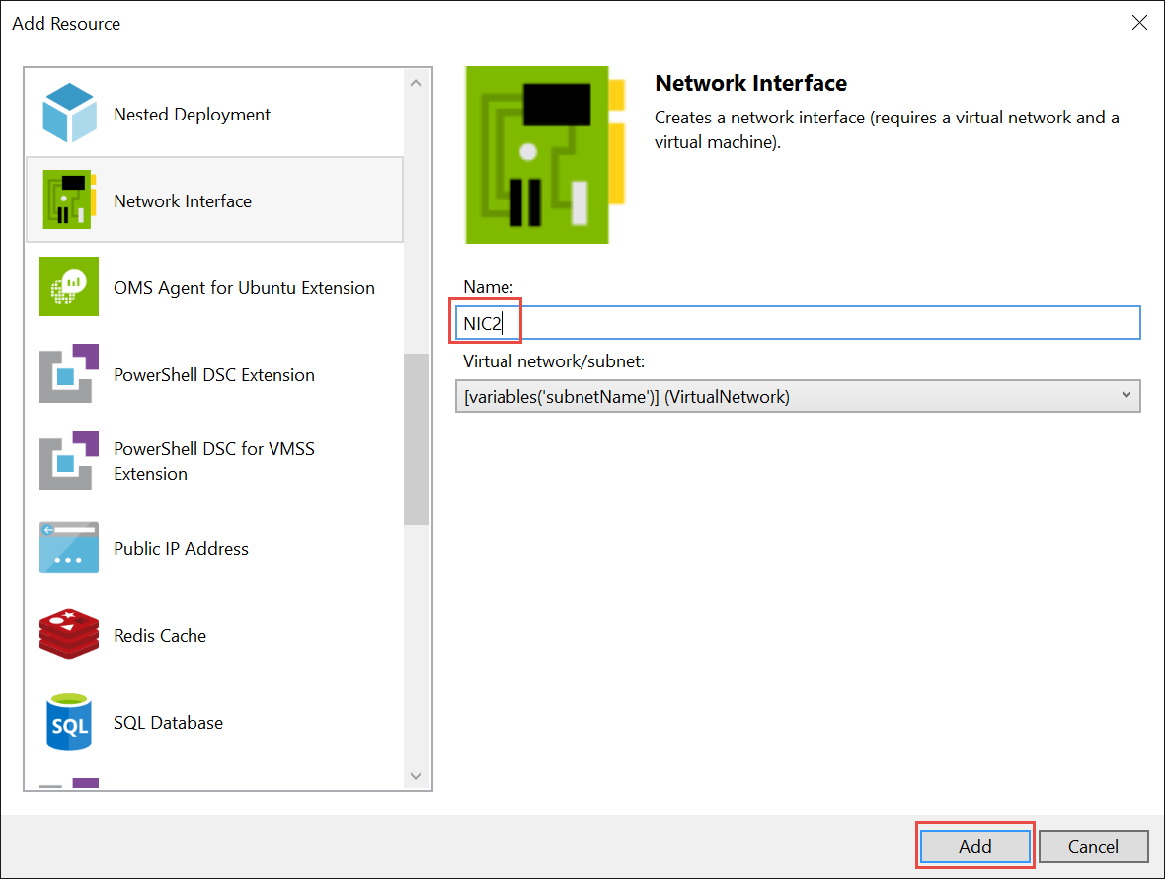

1. Next Right Click **ARMLabIntro** Project in Solution Explorer, then **Deploy**, **New Deployment**.

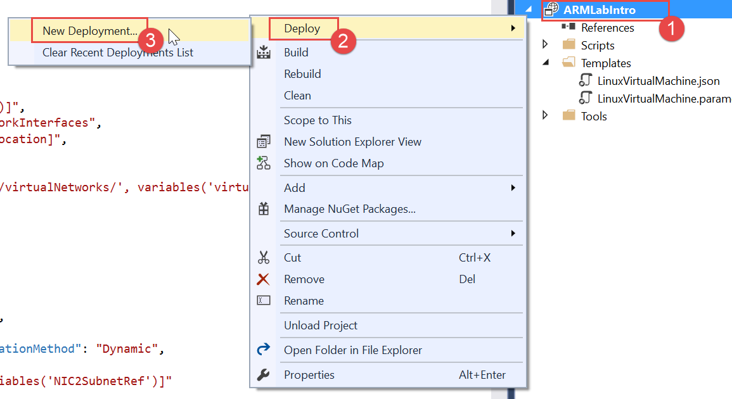

1. This will open the “**Deploy to Resource Group”** window where you may need to refresh your credentials.

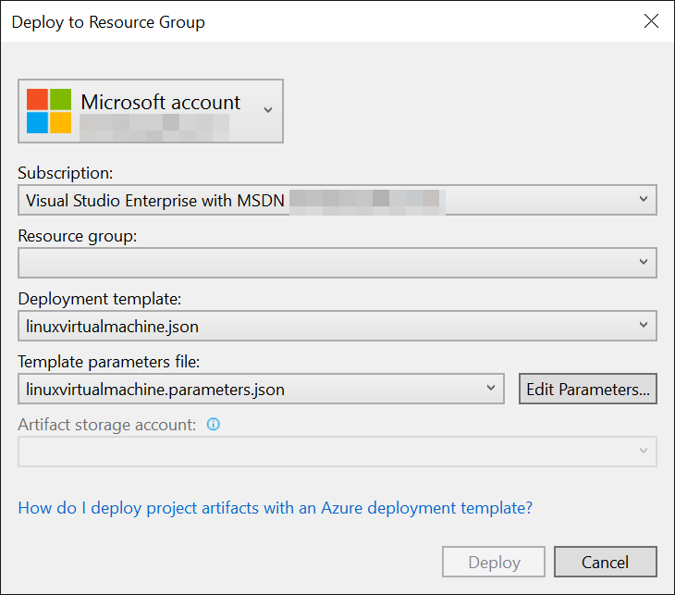

1. Click the Resource Group and Click **Create New**. Accept the Provided Resource Group Name of **ARMLabIntro** and chose West US (or the region or your choice).

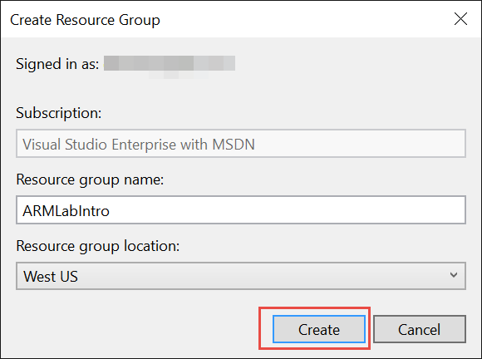

1. Next Click Deploy.

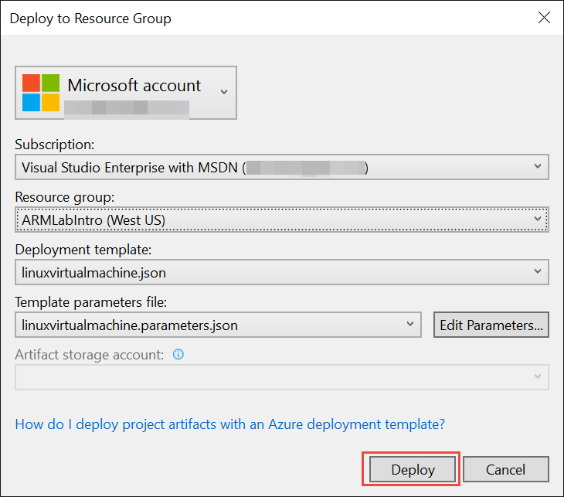

1. Fill in the required fields which includes a unique name for your VM.

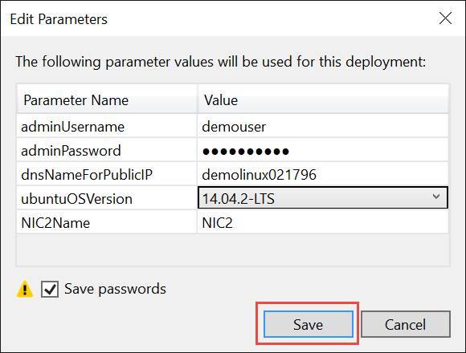

1. Move to the Output window and show the VM deployment taking place and look for the successful provisioning message and then the Successfully Deployed Template Message.

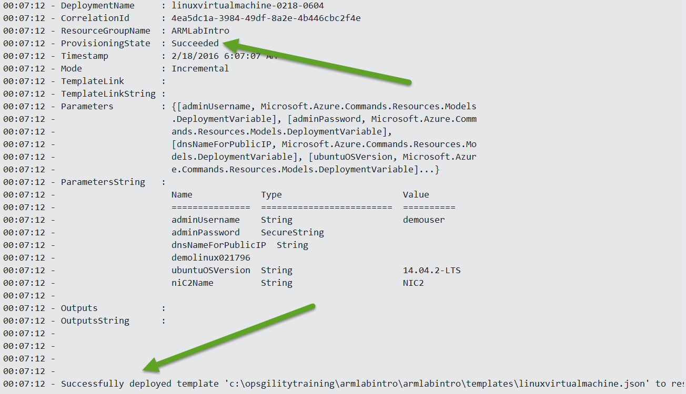

1. Browse to <http://portal.azure.com> and login with your Microsoft ID.
2. Find the **ARMLabIntro** Resource Group and open the blade. Show the new MyUbuntuVM that you implemented and the resources that are associated with the deployment.

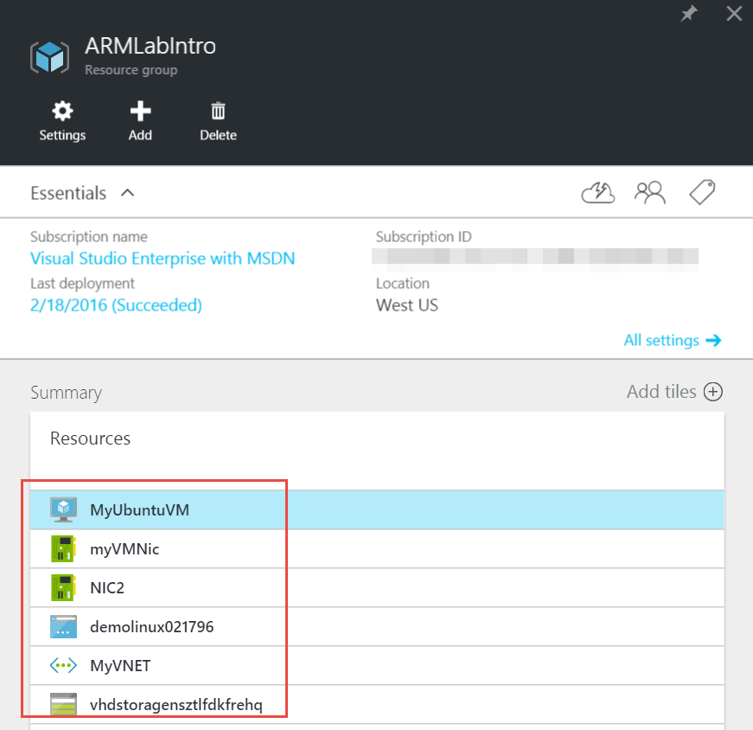

1. Click on the Public IP Address and open the Blade.
2. Find the address assigned to the **MyUbuntuVM**.

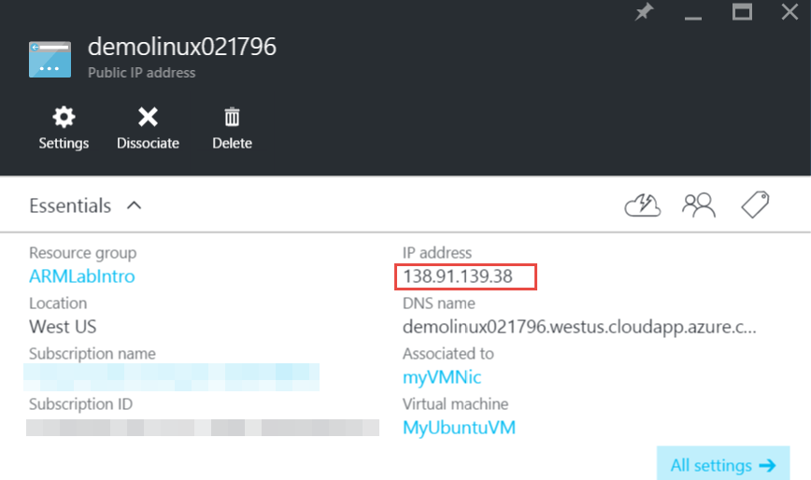

1. Open a terminal client such as puTTY, **enter the IP Address** and click **Open**.

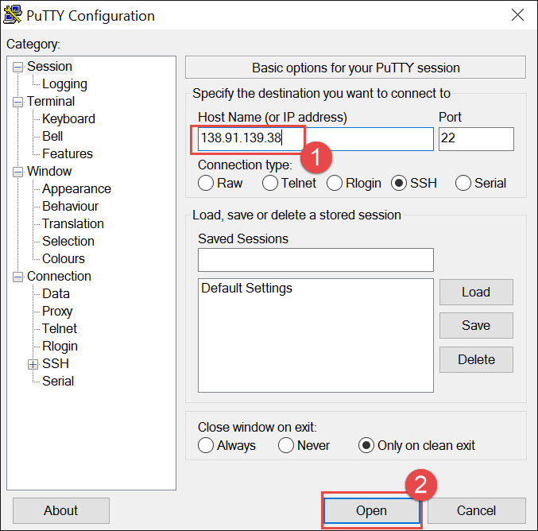

1. Click **Yes** to accept the servers RSA fingerprint.

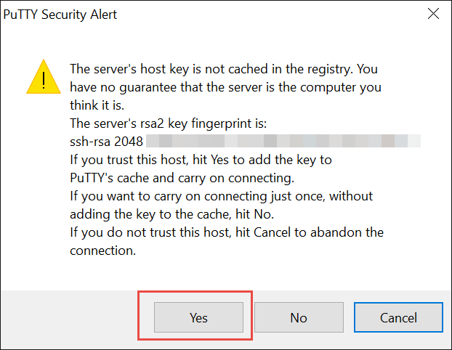

1. Enter the Username and Password to login to the Server

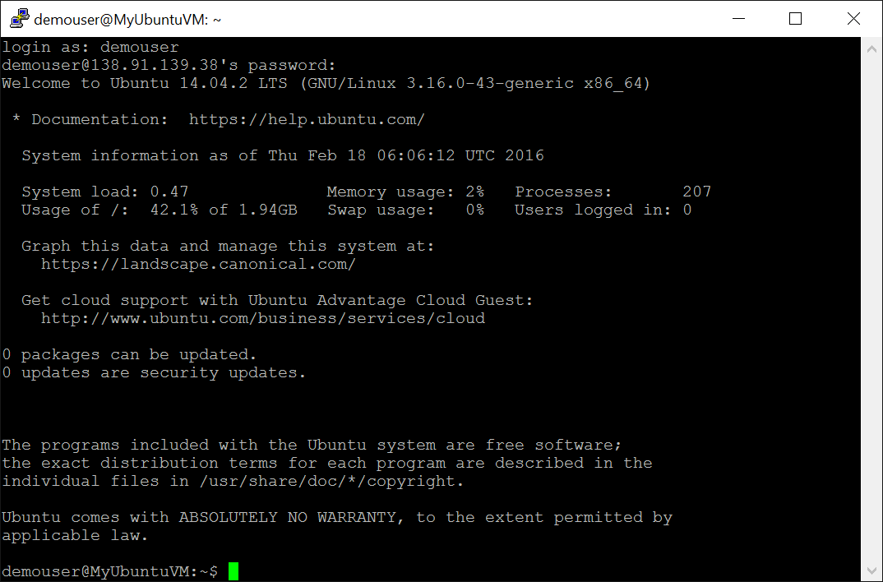

1. Type logout to exit from your connection to the server.

## Demo: Read-Only and Delete Resource Locks

In this demo, you will create a Read-Only Lock and show that only read actions can be performed. Then you will remove the Read-Only Lock and create a Delete Resource Lock showing that every other action except delete is allowed via the Resource Lock.

NOTE: A Resource Group with resources needs to be available. If the instructor has completed the Labs along with the students during the process of the course, there should be a few RGs available to choose from. If not, pre-stage a template deployment and deploy Quickstart template **101-vm-simple-windows** to have something available to demo Resource Locks.

* 1. If not already logged in to the Azure Portal, open a browser and browse to <https://portal.azure.com>. Sign in with the account used for the instruction of the course.
  2. Select **Resource groups** from the left hand menu pane on the Azure Dashboard.  
     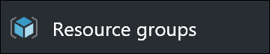
  3. From the resulting list of Resource Groups, select **OpsVmRmRG**.   
     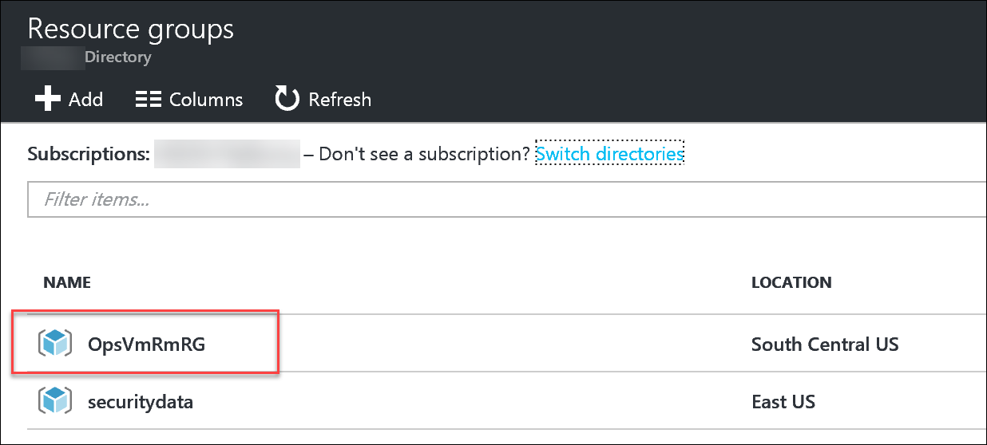
  4. Select **Locks** under the **SETTINGS** tab.

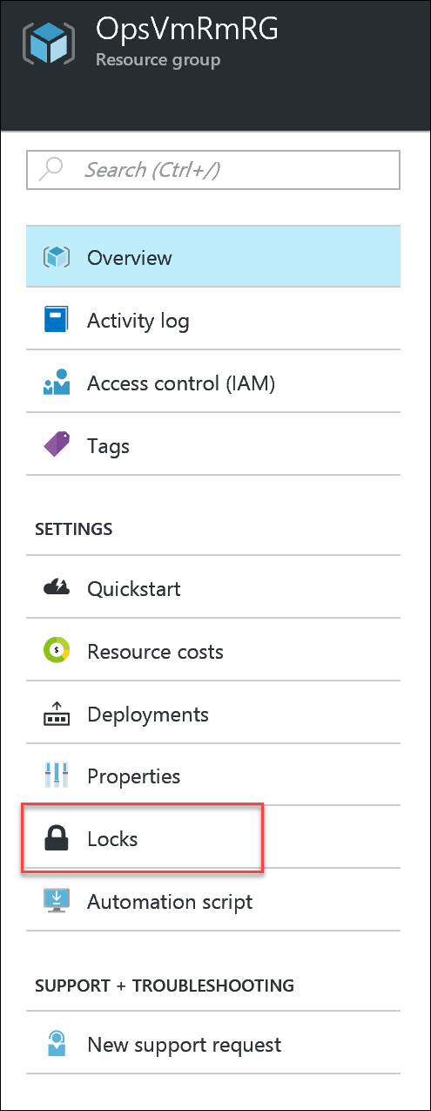

* 1. Click the **+ Add** icon to add a Resource Lock.  
     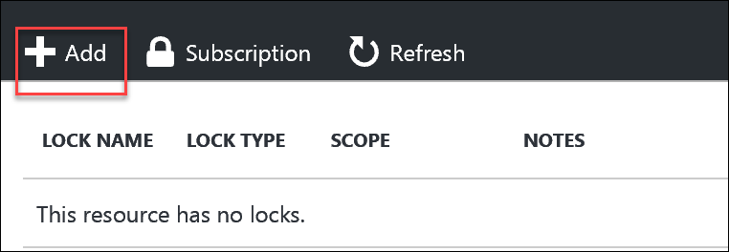
  2. Enter the following information:

|  |  |
| --- | --- |
| * + - Lock name: **ROLock**     - Lock type: **Read-only** (from the dropdown)     - Notes: **Read-Only Lock Demo**     - Click the **OK** button to create the Lock |  |

* 1. Once the Lock is created, show the students that it applies to the resources in the Resource Group as the Locks inherit to the resources below.
  2. To do this, click on **Resource groups** again in the left hand pane of the menu on the Azure Portal. Then click on **OpsVMRmRG** and select a resource in the resulting list of resources. Then click on **Locks** for that resource and show the inherited Read-Only Lock.  
     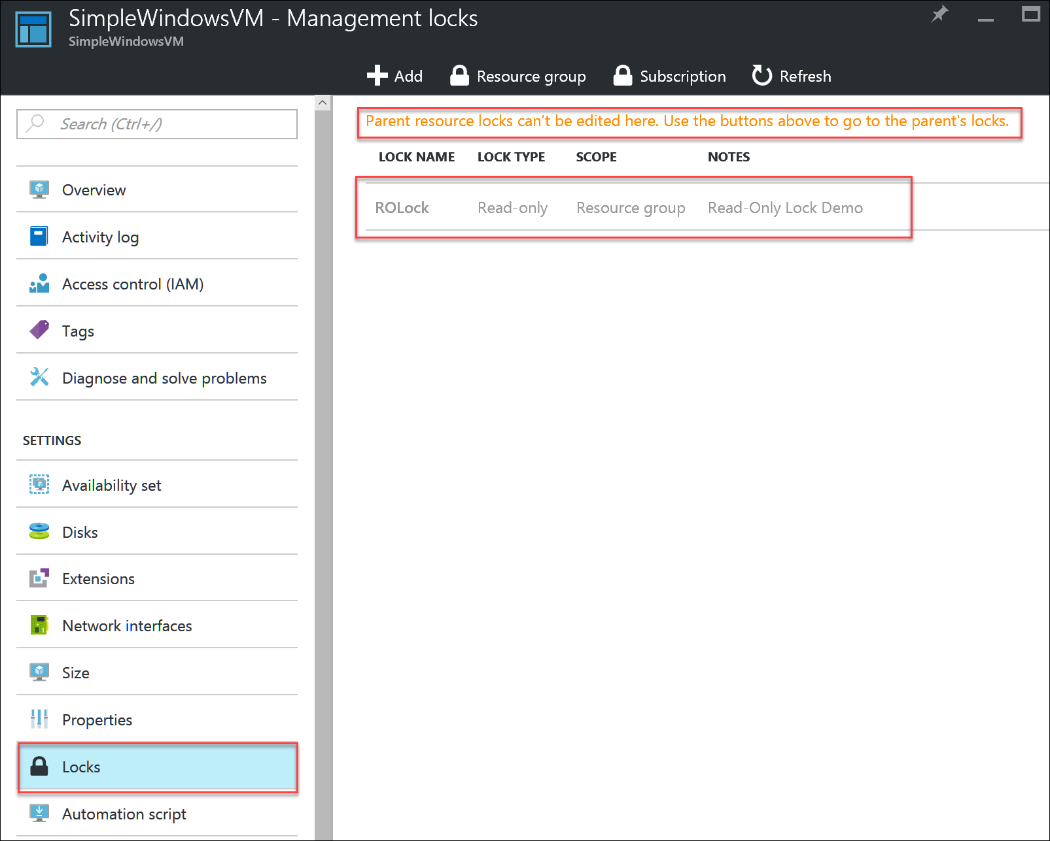
  3. Try to deploy a new resource of your choice into the **OpsVmRmRG** resource group by hitting the **+ Add** icon for the RG and attempt to deploy.
  4. The attempt will error with a result close to the following screenshot:  
     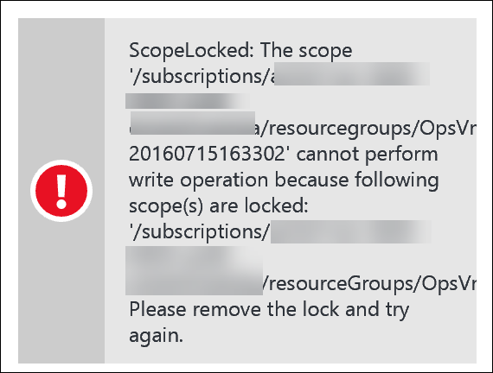
  5. Point out the reason the operation was blocked due the lock.
  6. Try to delete an object and note the resulting error due to the Read-Only lock.
  7. Go back to the RG, delete the Read-Only Lock and then create a Delete Lock.

|  |  |
| --- | --- |
| * + - Lock name: **DelLock**     - Lock type: **Delete** (from the dropdown)     - Notes: **Delete Lock Demo**     - Click the **OK** button to create the Lock |  |

* 1. This time, add a resource of your choice to the Resource Group and show that this succeeds as the only issue that is locked is now the **Delete** option.
  2. After creating the resource successfully, attempt to delete the resource. Show the students that the resource is blocked from being deleted, but can be created.
  3. Finally, delete the Delete Lock to remove the locks on this RG.